HEALTH AFFAIRS FORM 4
HEALTH AFFAIRS FORM 4 NONTENURE-TRACK PRACTICE PLAN FACULTY APPOINTMENT TO TITLES IN SECTION 1.623 AND 1.624(c), CHAPTER III, PART ONE, REGENTS R&R
Name and Address Date MEMORANDUM OF APPOINTMENT, 20__ - ____ Fiscal Year The Board of Regents of The University of Texas System has authorized your appointment to the following
position at The University of Texas ____________________________________:
Academic Title Tenure Status Nontenure-Track Clinical Appointment Department Period of Percent Time Budget Period Appointment
Base Compensation Practice Plan Total Compensation Augmentation
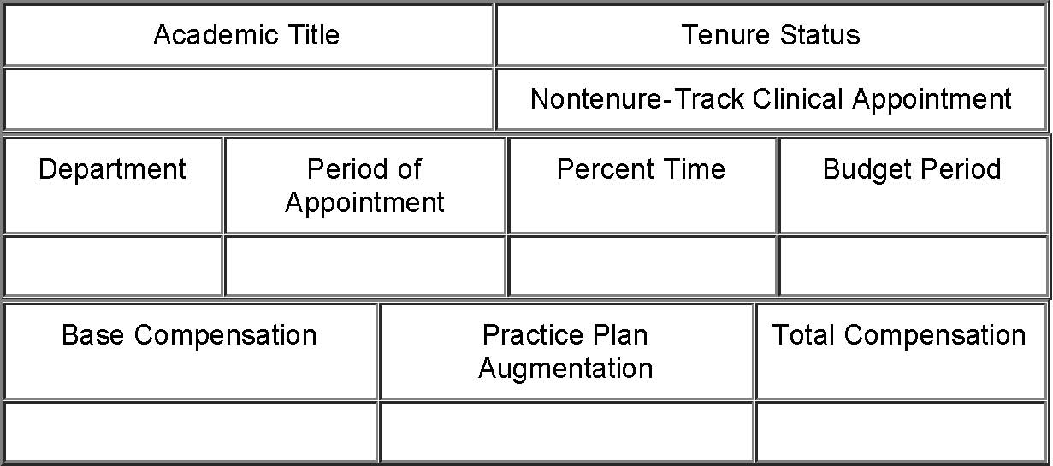
This appointment is subject to the provisions of the Rules and Regulations of the Board of Regents of The University of Texas System, Regental and U.T. System policies, the rules and regulations of the University, and applicable state and federal laws and regulations. The total compensation is the gross amount for the indicated budget period only and is subject to deductions required by state and federal law and, if permitted by law, other deductions that you may authorize. The obligation for payment of all or any portion of the compensation that is payable from contracts, grants, gifts, bequests, or endowments is dependent upon receipt of those funds. You also will receive such employee benefits as may be authorized by applicable laws and by the Bylaws of the [Medical Service, Research and Development Plan or Physician Referral Service]. The practice plan augmentation may be decreased during the budget period when the current income to the practice plan is insufficient to meet existing practice plan commitments..
Your appointment will terminate without prior notice at the end of the stated period of appointment. Appointment for an additional period is at the discretion of the University. The stated compensation may be increased or decreased in any subsequent offer of appointment you may receive.
Please indicate acceptance of this appointment by signing and dating this Memorandum in the space indicated below and return it to the Office of the ___________________ by ________________, 20__, in order that your name may be placed on the payroll for the next fiscal year.
A revised Memorandum will be sent if there is a change in your status during the indicated budget period.
Chair of Department *
file:///C|/Users/nburke/Documents/HTML%20to%20be%20converted/haform4.htm[4/29/2013 2:27:21 PM]
HEALTH AFFAIRS FORM 4
President
I accept this appointment ___________________________________ Date: ________________________
* If the administrative unit does not have a Chair substitute the title of the head of the unit.
Last Updated: November 21, 2002 Return to OGC Standard Contracts Page
file:///C|/Users/nburke/Documents/HTML%20to%20be%20converted/haform4.htm[4/29/2013 2:27:21 PM]

