HEALTH AFFAIRS FORM 4A
HEALTH AFFAIRS FORM 4A* NOTICE OF INTENT TO OFFER NONTENURE-TRACK PRACTICE PLAN REAPPOINTMENT TO TITLES IN SECTIONS 1.83 AND 1.84(c), CHAPTER III, PART ONE, REGENTS’ R&R
Name and Address Date
MEMORANDUM OF APPOINTMENT, 20__ - ____ Fiscal Year
It is the intention of The University of Texas System to offer you an appointment to the following position for the indicated period.
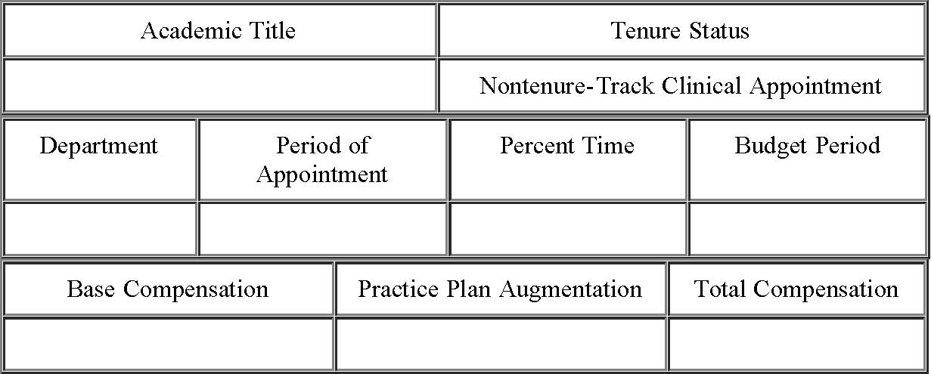
Your appointment to the above referenced position is dependent upon the approval of the Board of Regents of The University of Texas System. After approval by the Board of Regents, you will receive an official Memorandum of Appointment.
Chair of Department **
President
*NOTE: This form is not to precede an initial appointment to these titles. Use this form only to offer current appointees a reappointment. Health Affairs Form 4 is to be used for initial appointment and for reappointment.
** If the administrative unit does not have a Chair substitute the title of the head of the unit.
Last Updated: April 21, 2000 Return to OGC Standard Contracts Page
file:///C|/Users/nburke/Documents/HTML%20to%20be%20converted/haform4a.htm[4/29/2013 2:27:28 PM]

