HEALTH AFFAIRS FORM 8
HEALTH AFFAIRS FORM 8 NONTENURE-TRACK NONPRACTICE PLAN FACULTY APPOINTMENT TO TITLES IN SECTION 1.83 AND 1.84, CHAPTER III, PART ONE, REGENTS R&R
Name and Address Date
MEMORANDUM OF APPOINTMENT, 20__ - ____ Fiscal Year
The Board of Regents of The University of Texas System has authorized your appointment to the following position at The University of Texas ____________________________________:
Academic Title Department Tenure Status Nontenure Track Appointment Period of Appointment Percent Time Budget Period
Base Compensation Other Compensation Total Compensation
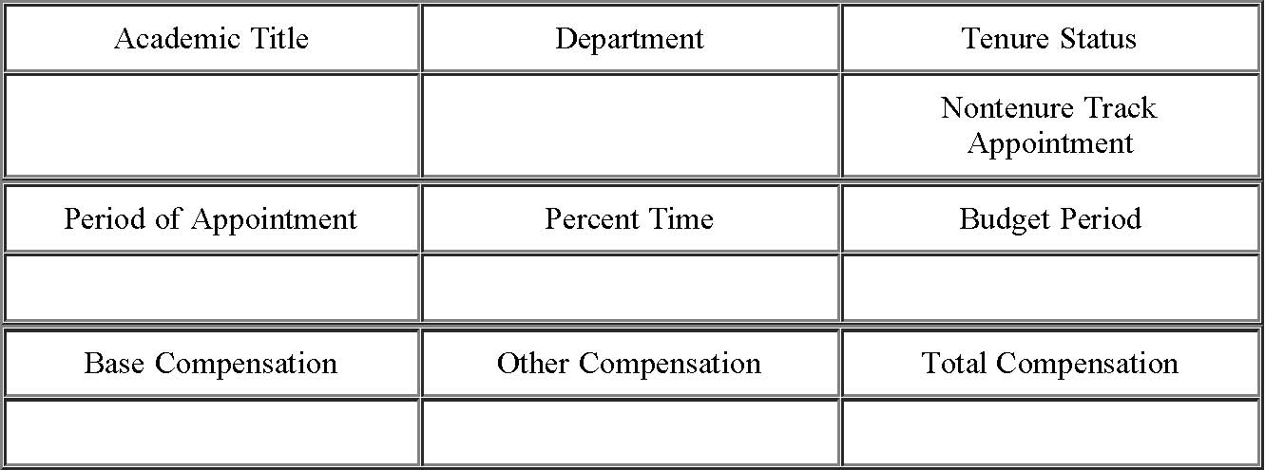
This appointment is subject to the provisions of the Rules and Regulations of the Board of Regents of The University of Texas System, Regental and U.T. System policies, the rules and regulations of the University, and applicable state and federal laws and regulations. The total compensation is the gross amount for the indicated budget period only and is subject to deductions required by state and federal law and, if permitted by law, other deductions that you may authorize. The obligation for payment of all or any portion of the compensation that is payable from contracts, grants, gifts, bequests, or endowments is dependent upon receipt of those funds. You also will receive such employee benefits as may be authorized by applicable laws.
Your appointment will terminate without prior notice at the end of the stated period of appointment. Appointment for an additional period is at the discretion of the University. The total compensation may be increased or decreased in any subsequent offer of appointment you may receive.
Please indicate acceptance of this appointment by signing and dating this Memorandum in the space indicated below and return it to the Office of the ___________________ by ______________, 20__, in order that your name may be placed on the payroll for the next fiscal year.
A revised Memorandum will be sent if there is a change in your status during the indicated budget period.
Chair of Department * President
file:///C|/Users/nburke/Documents/HTML%20to%20be%20converted/haform8.htm[4/29/2013 2:27:31 PM]
HEALTH AFFAIRS FORM 8
I accept this appointment ___________________________________ Date: ________________________
* If the administrative unit does not have a Chair substitute the title of the head of the unit.
Last Updated: April 21, 2000 Return to OGC Standard Contracts Page
file:///C|/Users/nburke/Documents/HTML%20to%20be%20converted/haform8.htm[4/29/2013 2:27:31 PM]

